# Module 7: Literacy Practices

## Before you read

This week we have another reading-intensive week. In addition to Chapter 7 of your textbook, you must also read Patricia Baquedano-López’ chapter on literacy practices and Naomi Baron’s [article](http://cacm.acm.org/magazines/2005/7/6185-instant-messaging-and-the-future-of-language/pdf?dl=no) on instant messaging and the future of language. Use your time wisely and pace yourself. As you read, try to think about the role that reading and writing plays in your life. Do you remember what it was like to learn how to read? **Pg. 141** in the book contains a series of examples of linguistic practices involving orality AND literacy. Can you think of any other examples from your own experience?

In this module, we will learn about how literacy has been conceptualized by literacy scholars. Literacy scholars are a diverse group of people that includes linguists, sociolinguists, and linguistic anthropologists but also educators and psychologists. We will consider several ethnographic examples of what studying literacy practices can tell us about human behavior, introduced both in the textbook and in the assigned readings for this week. I will also introduce an interesting historical example from my own work.

Remember, **bolded** items are likely to be featured in quizzes and exams and should be mentioned in your graded discussion posts.

## Focus Points

As you read, pay special attention to the following terms, concepts, and ideas:

* **Literacy events** vs. **literacy practices**
* **Autonomous** vs. **ideological** approaches to studying literacy
* **Computer-mediated communication (CMC)** and the debate surrounding it.
* **Historical linguistics** and the study of ancient literacy practices.

## “Literacy Events” v. “Literacy Practices”

**Literacy events** are moments in which writing becomes part of subjects’ interactions –such as comparing notes with your friends on movie reviews you have read, studying as a group for exam, signing an online petition, posting, “liking,” and sharing things on Facebook, tweeting.

**Literacy Practices** are the general “rules” that regulate literacy events. In other words, they are the cultural way we use written language –such as grammar, netiquette, styles (APA, MLA, AAA), situational writing (e.g., academic vs. informal writing depending on the situation), or any regular practice associated with literacy.

Turn to page 143 and read the section on **Pema Kumari’s letter**. How does this **literacy event** also illustrate a change in **literacy practices**?

## “Autonomous” vs. “Ideological” Approaches to Literacy

The **autonomous** model of literacy (associated with **Jack Goody** and **Walter** Ong) maintains that when a society becomes literate, the ***same* social and psychological effects will follow**. For these scholars, literacy is a sort of evolutionary step, whereby illiterate societies are unable to achieve the same kind of cognitive processes that literate societies have. This view is rejected by linguistic anthropologists, particularly in light research that suggests that different literacies are embedded in different kinds of social practices which lead to different cognitive effects.

The **ideological** model for studying literacy (associated with **Keith Basso**, **David Barton**, and **Brian Street** among many others) focuses on activities, events, and ideological constructs associated with particular manifestations of literacy. The goal is to produce a **situated** approach to studying language that lends itself quite well to **practice-centered** research.

## Literacy Studies and their Relevance to History

As you should know by now, I am an ethnographer of Yucatán, an area of the world known for its rich Maya heritage and traditions. In the course of my studies, I learned about the Ancient Maya, who had elaborate system of hieroglyphic writing:

Facsimile of the Dresden Codex showing Ancient Maya writing and a deity.

The Dresden Codex is the oldest book known in the Americas. The book we have today was written in the 11th or 12th century, but epigraphers and archaeologists believe it was copied from an original text written some three or four hundred years later. The Ancient Maya writing system features a combination of **phonetic symbols** and **logograms** (a graphic representation of a word). The writing system was still in use at the time of the Spanish conquest (in Yucatán, where the Dresden codex originated, this was in 1542, a full 50 years after Columbus’ voyage). Because the ability to write was limited to a very small number of elites, it probably died out within a few generations.

But…

Although the Maya stopped writing using the old system, they didn’t stop writing altogether!

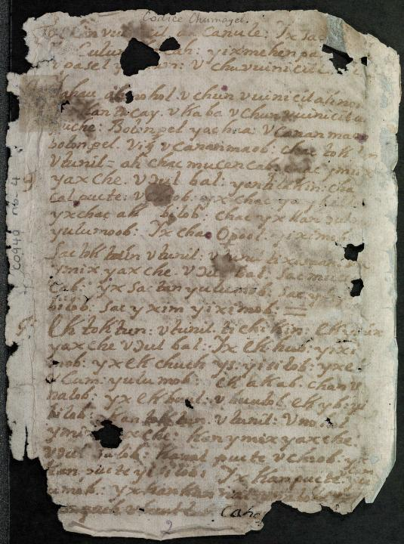

The Franciscans taught Maya youth how to write Maya using European script as part of their efforts to missionize. The picture above is a photograph of the **Chilam Balam of Chumayel**, a colonial book written in Yucatec Maya using European script. The book contains descriptions of rituals, history, and medicine written from the perspective of the Maya themselves. The authors of the *Chilam Balam* used the only tool they had at their disposal –a tool given to them by the Franciscans themselves – to resist the complete destruction of their way of life. These and the many other versions of the Chilam Balam produced in Yucatan throughout its colonial history are a powerful example of **historical literacy practices** and what they can tell us about human behavior.

## Examples of Literacy Research

The examples outlined below are presented by Ahearn in the textbook. In each instance, situated literacy research has revealed how the study of literacy practices and literacy events can affect people’s lives. Please take some time to review each of the following examples.

### Preschool literacy (Pg. 147-150)

### Love-letter writing (151-153)

### Instant-messaging (153-155)

## Disclaimer

The material presented in this module is not exhaustive; it is meant to function as a guide to our course materials. Concepts, key terms, and ethnographic examples that appear in our readings or that are discussed in future f2f classes can and will be used in assessments even if they are not specifically mentioned in this course module.